Design Document

MDW

Do you want to be a millionaire? (Group 5)

Yidi Wu

Iulian Toma  
Ji Nan

Contents

Architecture Diagram 2

Description of Interfaces 2

Class Diagram for Client 3

Class Diagram for Service 4

Sequence Diagram 4

1. Ask a Question 5

2. Ready to Play 6

**Architecture Diagram**

IGameplay

Gameplayserver

Gameplayclient1

Gameplayclient2

IGameplayCallback

**Description of Interfaces**

|  |
| --- |
| **<<interface>> IGamePlay** |
|  |
| + void AnswerQuestion(int qid)  + void CorrectAnswer(string name)  + bool CheckAnswer(Question q, string a)  + List<Question> GetQuestionList()  + List<Player> GetPlayerList()  + void CreateAPlayer(int id, string name)  + int GetCredit(Player p)  + void Finish()  + void SubscribeEvent()  + void WinnerEvent()  + void ShowFirstQuestion()  + Player Winner()  + int GetRemain(Player p)  + int AddPlayer(int id, string name, string password)  + bool CheckPlayer(int id, string pwd)  + string GetName()  + void FinishQuesion() |

|  |
| --- |
| **<<interface>>IGamePlayCallback** |
|  |
| + void ShowNextQuestion()  + void GameStart()  + void GameFinish(Player p) |

**Class Diagram for Client**

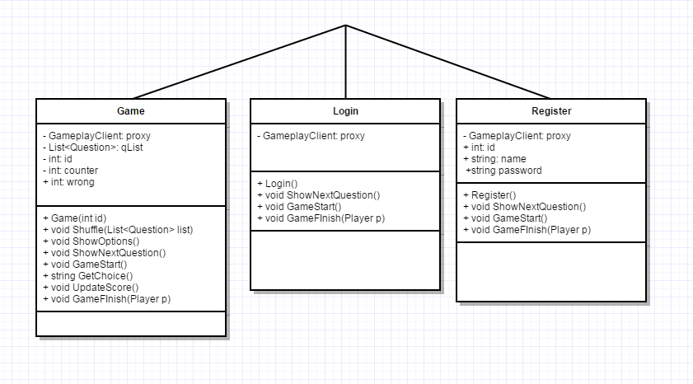

**Class Diagram for Service**

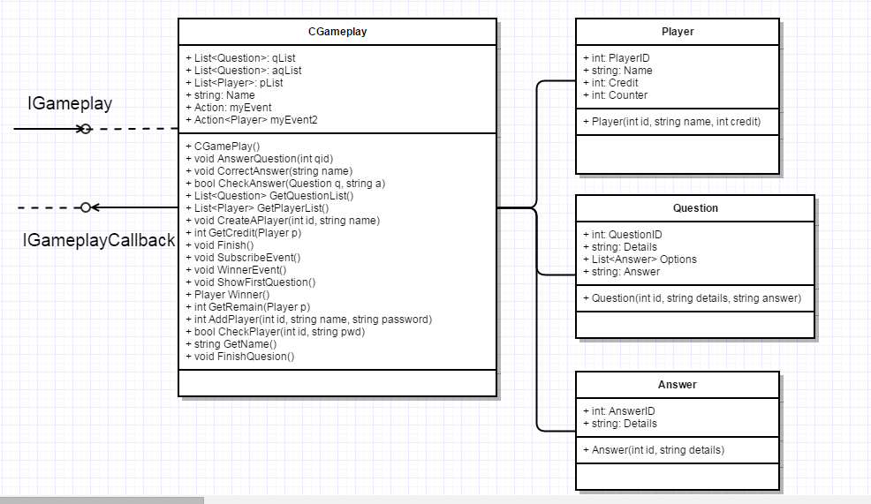

**Sequence Diagram**

1. **Ask a Question**



1. **Ready to Play**



1. **Register**

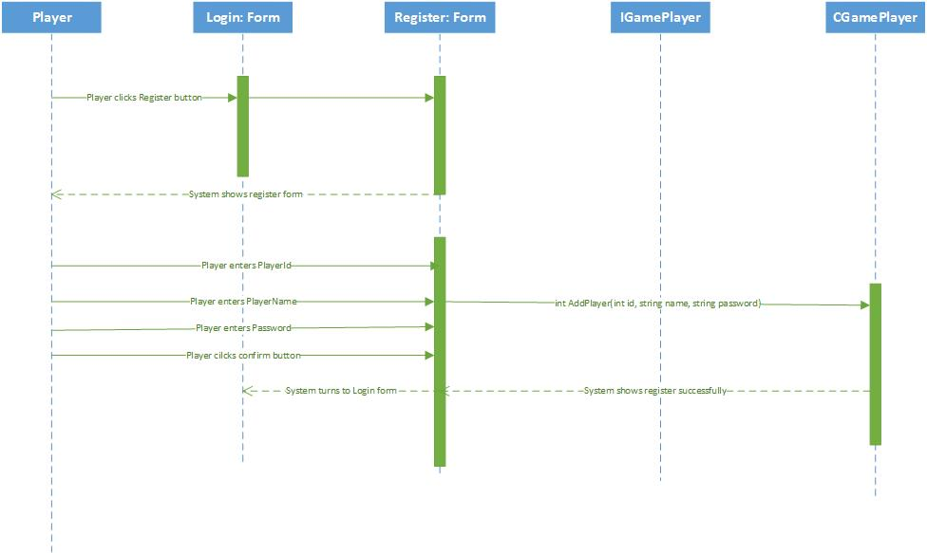

1. **Login**

